**DA ASSIGNMENT – 2**

**THE COGNOS HR SCORECARD: MEASURING SUCCESS IN TALENT**

**MANAGEMENT**

**NAME : PALANISELVAM M**

**REGISTER NO : 723920104301**

Uploading the dataset to Cognos Analytics:

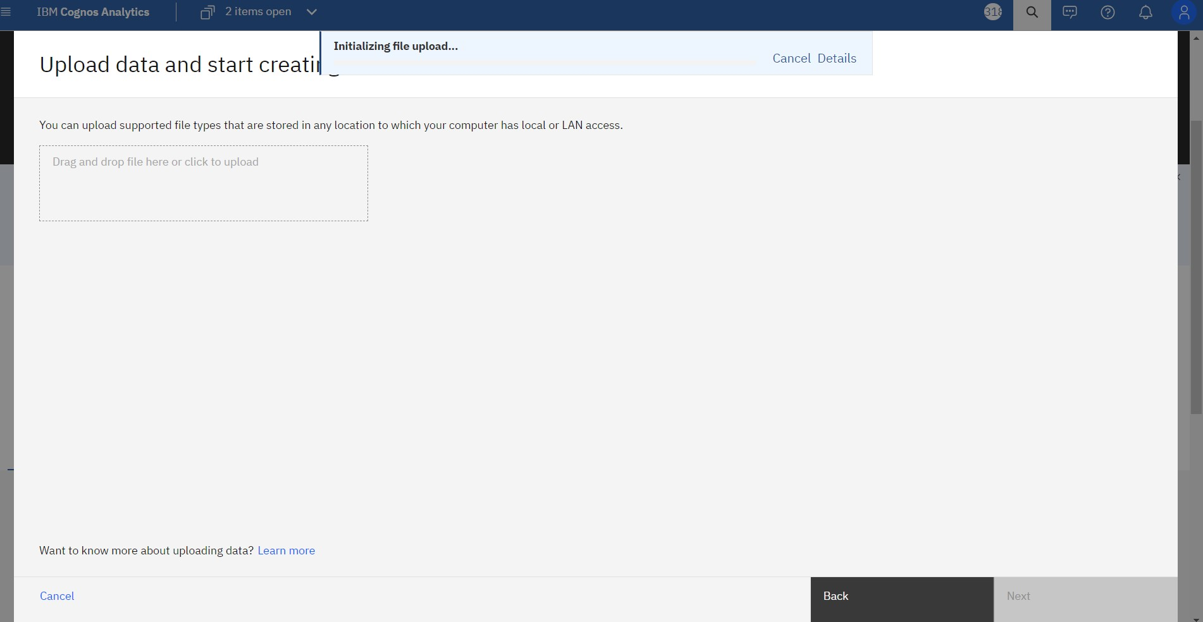

DASHBOARD :

